Lacock Primary School – Year 5/6 – African inspired musical instruments
Important Vocabulary |  | 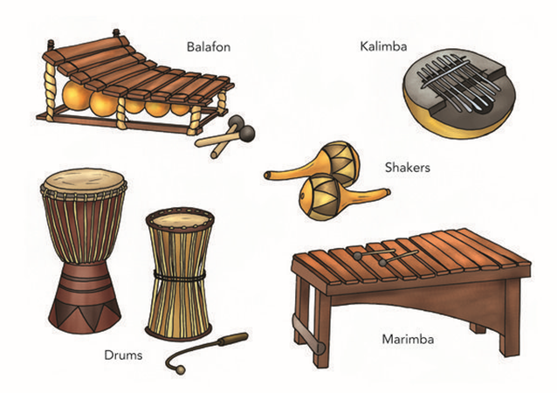 | Design process
Design criteria | Important goals which must be achieved, for a product to be successful. |  | 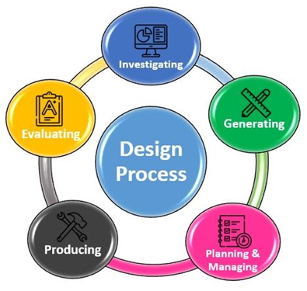
Evaluation | Judging the quality of the design and final product, as well as finding areas for improvement.
Talking drum | The talking drum is an hourglass-shaped drum from West Africa.
Kalimba | A wooden board with attached staggered metal tines, played by holding the instrument in the hands and plucking the tines.
Key Skills |  | Key Knowledge/Facts
- Designing  - Researching  - Evaluating and modifying  - Accurate measuring  - Assembling  - Joining |  | - To know why initial research is important.  - To know the stages of what has to be done, planning how to use materials, equipment and processes, and suggesting alternative methods of making if the first attempts fail  - To know how to evaluate their design ideas as these develop, bearing in mind the users and the purposes for which the product is intended, and indicating ways of improving their ideas.
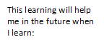
What I should already know:
Select from and use more specialist tools, techniques and equipment.
How to join and cut paper, card, wood, plastic in different ways.

