Lacock Primary School – Year 5/6 – D.T – My Green City
Important Vocabulary |  | 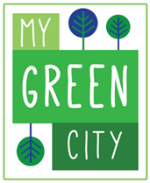 | What issues face modern cities? | 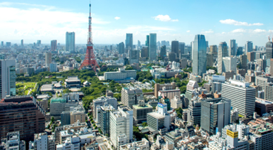 | Key Skills
sustainability | Using natural resources responsibly, so they support present and future generations. |  |  |  | Use research and develop design  criteria to inform designs which are innovative, functional and appealing.
infrastructure | Basic equipment and structures (such as roads and bridges) that are needed for a city to function properly.
inhabitants | People who live in a particular place. | 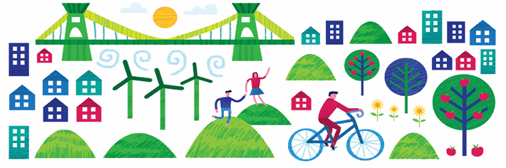 |  |  | What is a living wall?
plan | Drawing showing exactly what’s on the ground. |  |  |  | 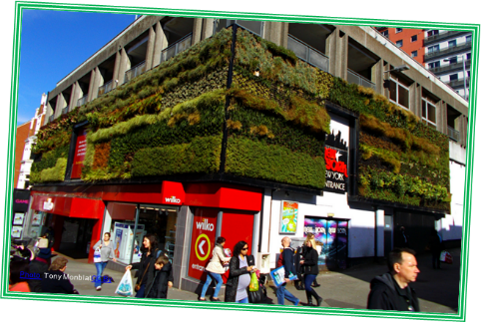
scale | Size of area represented by a map. E.g, 1:10,000 on a map means 1 mm is 10,000 mm in reality.
key | a list of symbols that appear on a map.
What is the high line in New York? |  | Key Knowledge/Facts
- To understand issues facing populations living in urban environments.
- To be able to generate a plan of their sustainable city with annotated and exploded diagrams.
- To generate a 3D model of their city, with features so that inhabitants can live more sustainably.
- To produce a city charter for all the residents living in their sustainable city.
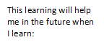
What I should already know:
To know how to make complex small worlds with blocks and construction kits.
construction kits.
How to collect research using surveys, questionnaires and interviews.

