Lacock Primary School – Year 5/6 – Art - Collage
Important Vocabulary |  | Mandy Barker  A British photographer. She is mostly known for work with marine plastic debris. Barker has worked alongside scientists in hopes of bringing awareness to the mass amount of plastic that is floating around in our oceans | 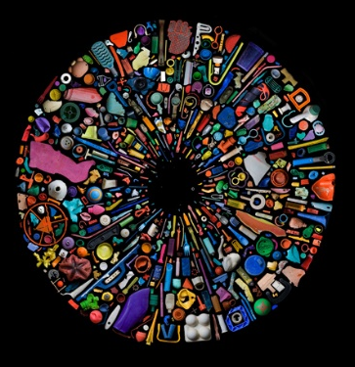 | Key Skills
Collage | A technique when different materials are assembled, creating a new whole. |  |  | - Use an artist as a starting point for their own work.  - Make connections between their own work and that of other artists.  - Discuss works of art using an increasing art vocabulary.
Painting with scissors | Henri Matisse’s famous explorations of colour and line exploded into energetic collages known as cut-outs.
ephemeral | Lasting for a short time | 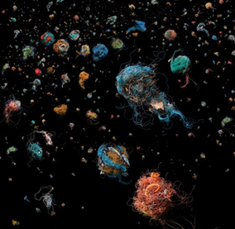 |  | Andy Goldsworthy
Art medium | The material with which an artwork is made. |  |  | 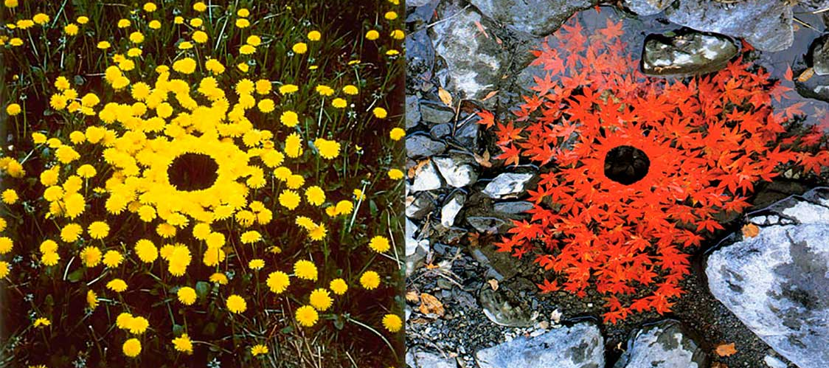
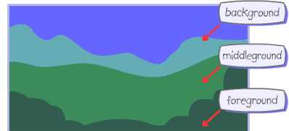
Painting with scissors  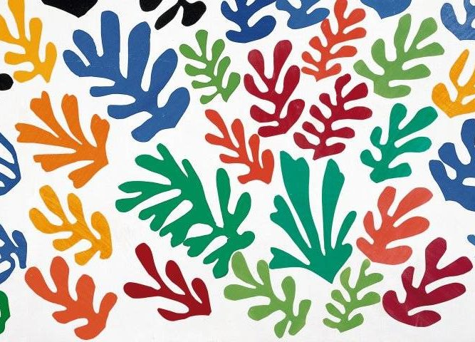 |  | Key Knowledge/Facts
- To learn how to combine, colour, tone, shape, texture and pattern.
- To know how to combine images and words to convey a message.
- To know how an artist would use their sketch book to develop an idea, prior to their main piece.
- To know the process of creating collages for Mandy Barker, Andy Goldsworthy and Henri Matisse.
- To know and be able to recognise key pieces for Mandy Barker, Andy Goldsworthy and Henri Matisse.

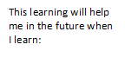
What I should already know:
How to create a collage using a multi-media package.
Different processes for cutting and joining.

