Lacock Primary School – Year 3/4 Beech Class. Rivers (geography)
Important Vocabulary |  | Include here images/pictures/maps/diagrams  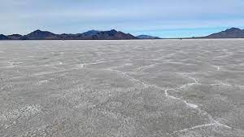  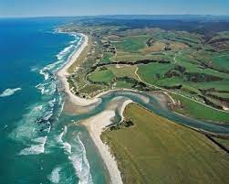  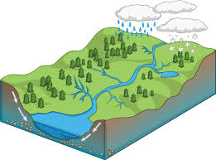  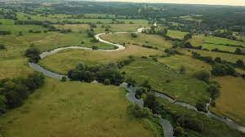 | Key Skills
source | The start of the river’s journey |  | - To understand the nature of a river that it flows downwards from high ground to the sea and that is has the power to erode and shape the landscape over time.  - To understand the nature of a river and how it changes on its journey from source to sea  - To understand the nature of a river and how it changes on its journey from source to sea.  - To understand the words evaporation and condensation in the water cycle and associate the rate of evaporation with temperature  - To understand what happens as a river reaches the coast, including: estuaries, deltas, mudflats and salt marshes.
mouth | The place where a river runs into a large body of water – such as a sea or ocean
Tributary | A river or stream that flows into a larger river or stream, or into a lake |  | Home learning
meanders | Twists and turns in the river’s journey |  | Choose…  - Create a model or diagram of the water cycle and how it works.  - Research some of the Great Rivers from around the world. Where is their source (start) and where is the mouth (end)? What places does the river flow through?
Salt marshes | Salt marshes are coastal wetlands that are flooded and drained by salt water brought in by the tides.
delta | A landform created by rivers depositing mud from a fast flowing river to a slow moving river
erosion | The slow destruction of land and rocks caused by the river and water
Water cycle | Show the continuous movement of water between the earth (rivers, seas, oceans) and the atmosphere (sky)
What I should already know:
This learning will help me in the future when I learn:
To understand how rivers help civilisations. To name great rivers around the world.
That rivers are a moving body of water that flows into another body of water. Name some main rivers in the UK and the world

