Lacock Primary School – Year 3/4 Beech Class. Rivers – Claude Monet (Art)
Important Vocabulary |  | Include here images/pictures/maps/diagrams  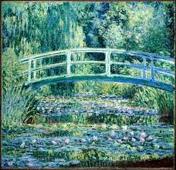  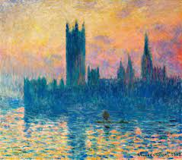  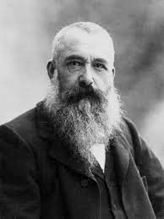  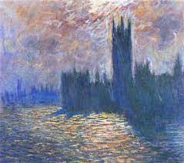  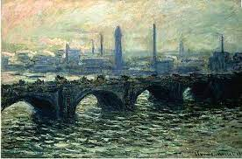  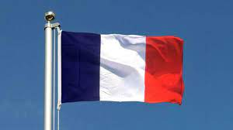 | Key Skills
Claude Monet | French painter who was the founder of Impressionist painting. |  | - To understand and explore how Claude Monet used light and colour to create impressions of the River Thames.  - To investigate the painting style of Claude Monet and in particular the way in which he captured light reflecting on water.  - To understand and explore how Claude Monet used light and colour to create impressions of outdoor scenes, painting ‘en plein air’  - To gain a deeper understanding of the work of Claude Monet and paint a picture of the River Thames in his impressionist style
River Thames | A large river running through London.
scene | A place where an event takes places, a particular view in a painting or photograph.
reflected | An image that is ‘thrown back’ from a surface or a mirror.
Acrylic paints | Paints used for painting on a range of surfaces.
horizontal | Parallel to the surface of the earth or the horizon
en plein air | Painting in the outdoors!
impressionism | A style of painting, started in France. Painted quickly using short brush strokes and unmixed colours.
What I should already know:
This learning will help me in the future when I learn:
To use a range of media to recreate landscapes.
A range of artists from the UK – Sonia Boyce, Gainsborough

