Lacock Primary School – Year 3/4 Beech Class. The Romans – Mosaics and Chariots (Art / DT)
Important Vocabulary |  | Include here images/pictures/maps/diagrams  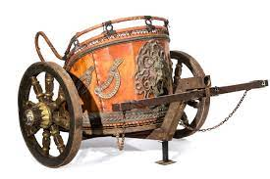  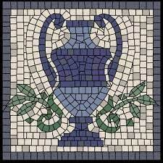  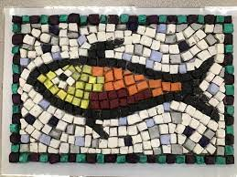  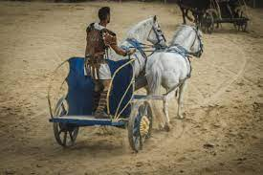  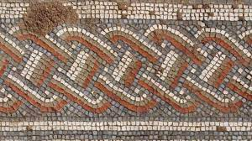  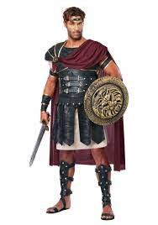  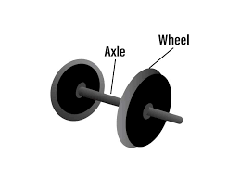  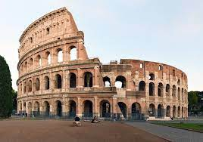 | Key Skills
Mosaics | A way of decorating a surface with pictures and patterns using little tiles made from stone, glass or tiles. |  | - To understand that different border patterns are used in Roman mosaics.  - To design a border for a printed mosaic and to evaluate the finished piece.  - To design a central motif for a printed mosaic and to evaluate the finished piece.  - To investigate Roman entertainment from a range of sources.  - To develop ideas and designs of moving vehicles through discussion and prototypes.  - To join wheels and axels effectively, choosing appropriate materials and explain how they work.  - To generate a design for a Roman chariot based on research.  - To safely and accurately select tools and equipment to build a Roman chariot.
Border | The strip around the edge of something. A border can be used as a decoration on fabric or crafts.
Motif | The dominate feature in a decorative piece of work.
Gladiators | A man in ancient Rome who fought other men or animals, often to the death to entertain an audience
Colosseum | A large building or theatre used for entertainment events.
Axle | A bar or shaft on which a wheel or wheels turn.
Circus Maximus | An ancient Roman chariot-racing stadium in Rome.
Criteria | A standard or test by which you build, judge or decide from. The criteria for a chariot would be: strong, moveable wheels, can be pulled by horses, fast
What I should already know:
This learning will help me in the future when I learn:

Basic DT skills for designing and evaluating (Viking Longships)

