Lacock Primary School – Year 5/6 – Global Eye on the World
Important Vocabulary |  | 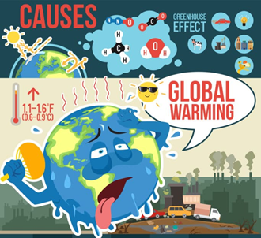 | Key Skills
climate | Climate is the long-term weather pattern in an area, typically averaged over 30 years. |  | Critically evaluate responses to local geographical issues or global issues and events.  Ask and respond to questions such as: What happened in the past to cause that? How is it likely to change in the future?
Carbon footprint | A carbon footprint is the total greenhouse gas emissions caused by an individual or organization.
Renewable energy | Energy from a source that is not depleted when used, such as wind or solar power. |  | What can we do differently?
Non-renewable energy | Non-renewable energy comes from sources that will run out or will not be replenished for thousands or even millions of years. |  | 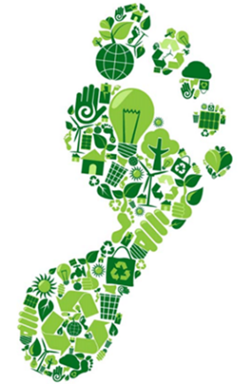
Global warming | Increase in the temperature of the earth's atmosphere, caused by high levels of carbon dioxide.
What are the effects of climate change?  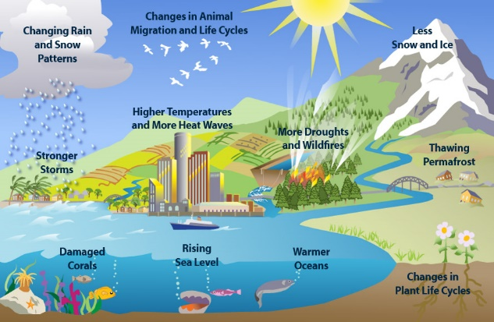 |  | Key Knowledge/Facts
- To know how our planet has changed in the last 50 years.
- To know issues facing our planet in 2022 with regards to our climate, to know what individuals and governments are doing to address it.
- To know how to calculate our carbon footprint and how to reduce it.
- To know what we can pledge as individuals and as a school to help.
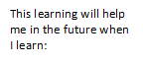
What I should already know:
To understand ways in which we are connected to other countries, including through trade.
To know the location of the North and South Poles. To know the climate in these areas and how it affects the lives of the animals, plants and humans.

