Lacock Primary School – Year 5/6 – Computing – Variables in Games
Important Vocabulary |  | 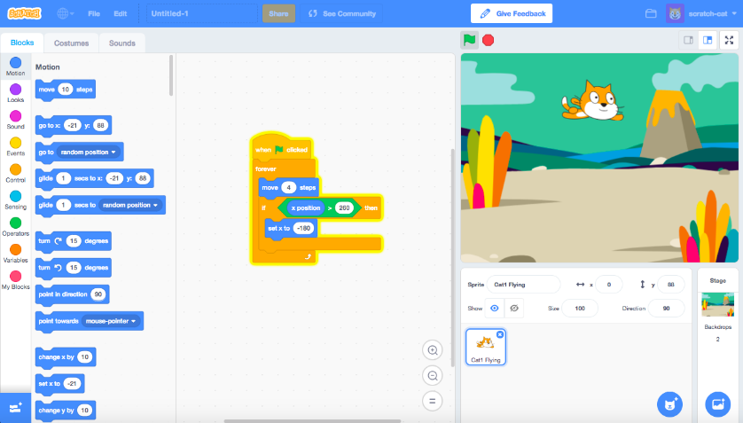 |  | Key Skills
Variable | A program variable is a placeholder in memory for a single value. A variable has a name and a value. The value of a variable can be changed. |  |  | - problem solving  - creative thinking  - self-expression  - collaboration
Programming | Writing a group of instructions for a computer to execute. | Sprites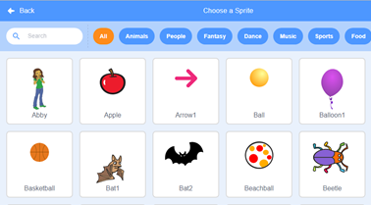 | Backgrounds | How will you use variables?
Scratch | Scratch is a block-based coding platform. |  |  | 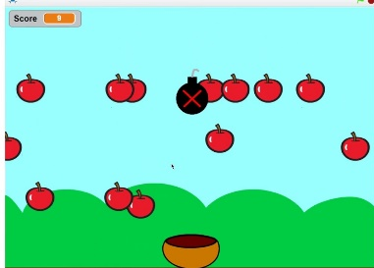
Sprites | Sprites are the images on a Scratch computer program screen.
Scratch Blocks  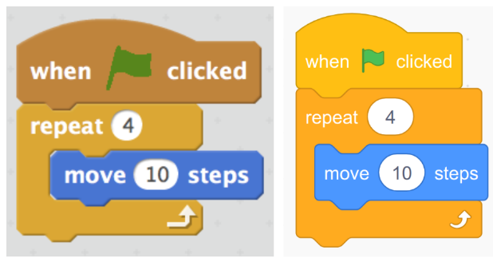 |  | Key Knowledge/Facts
- To define a ‘variable’ as something that is changeable.
- To explain why a variable is used in a program.
- To choose how to improve a game by using variables.
- To know how to design a project that builds on a given example.
- To know how to identify ways that my game could be improved.
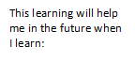
What I should already know:
How to use given commands in different orders to investigate how the order affects the outcome.
KS3 I will independently design and apply programming constructs to solve a problem.

