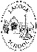
Lacock Primary School – Year 5/6 – Art of Africa – Focus Printing
Important Vocabulary |  | Adinkra Symbols  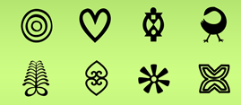 | Benin Clay Tiles  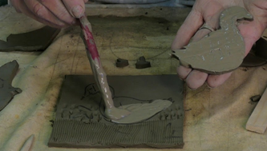 | Key Skills
Ghana | West African Country |  |  | - To be able to alter and modify their work as necessary.  - To select colours and symbols for meaning.  - To make links between their work and that of other artists.
Adinkra symbols | These are symbols from Ghana with special meanings.
Printing block | A tool used for creating repeating patterns on textiles. | 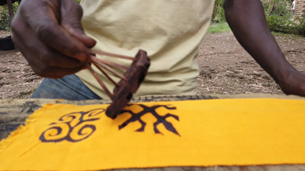 | 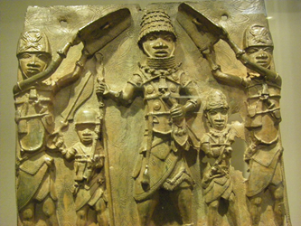 | How can you join pieces of clay?
Relief printing | Printing created when you carve into a printing block. |  |  | 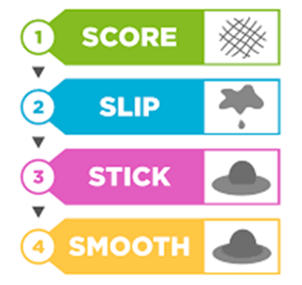
Score | To scratch hatch marks onto clay to join pieces together.
Slip | Liquid clay used to join pieces of pottery together.
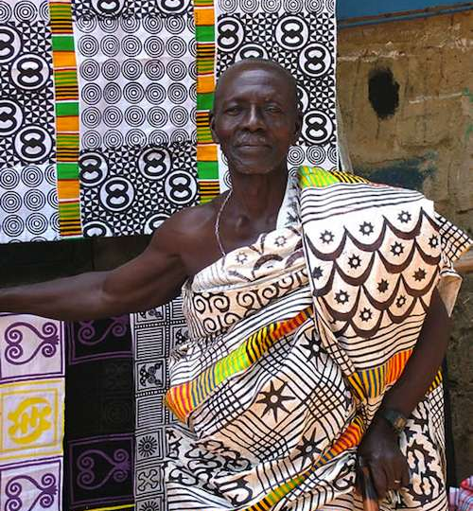 |  | Key Knowledge/Facts
- To know key features of a cultural piece and what they might represent.
- To know which tools and techniques are needed to make a clay tile.
- To know how to use the score, slip, stick and smooth technique to join clay.
- To know why Adinkra symbols are used in Ghanaian artwork.
- To know what a few Adinkra symbols mean.
- To know the process of creating a printing block.

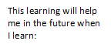
What I should already know:
When I continue to learn about different movements in art history.
How to print using natural and man-made objects. objects.

