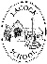
Lacock Primary School – Year 3/4 Beech Class. The Romans
aqu
8000BCE
1939-45
1914-18
Now
1837
1666
1485
1066
790 CE
43 CE
800 BCE
2300 BCE
Vikings
Tudors
Victorians
Normans
Romans
Bronze Age
Iron Age
Stone Age
Great Fire of London
Tudors
World War II
World War I
Modern Day
Important Vocabulary |  | Include here images/pictures/maps/diagrams  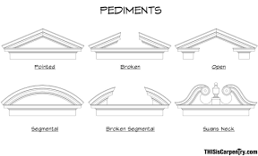  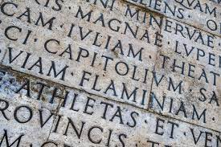  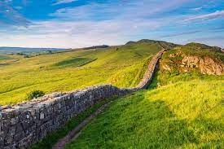  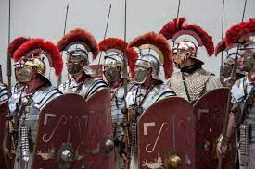  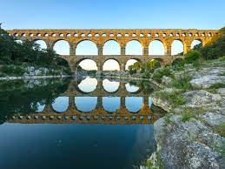  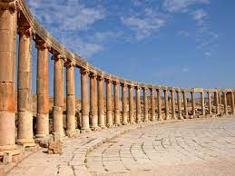 | Key Skills
Primitive | A very simple way of living, living in houses made from mud and grass. |  | - To begin to understand what life was like in Iron Age Britain.  - To understand the importance of the Roman army in the expansion of the Roman Empire to Britain.  - To learn about what life was like for Roman soldiers in Britain.  - To know that the Romans used the Latin language.  - To know that artefacts can help us to understand what life was like for people in Roman Britain.  - To understand that life changed in Britain after the Romans invaded.  - To become familiar with Roman architectural style.  - To recognise some famous Roman buildings and remains.  - To understand how arches were used in construction and why they are so strong.  - To understand how the Romans built many roads, many of which still exist.  - To develop understanding around the construction of aqueducts to bring fresh water into towns and cities.  Additional facts / skills
Roman Empire
Invasion | An act of intruding into another country or people’s lives.
Hadrian’s wall
Latin | The language of ancient Rome.
Artefacts | Objects made by human beings especially from the early periods.
Pediments | A low pointed or curved top on top of wall, window or door.
Colonnades | A series of columns that hold up a roof or a beam.
Architecture | The style or way that a building has been created.
Aqueducts | A structure like a bridge for carrying a waterway or a pipe across a river or valley.
What I should already know:
This learning will help me in the future when I learn:
The Normans
The Tudors
The Victorians

What life was like in the Stone Age, Bronze Age and
the Iron Age.
The Viking invasion into Britain.

