Lacock Primary School – Year 3 and 4 RE Sikhism
Important Vocabulary |  | 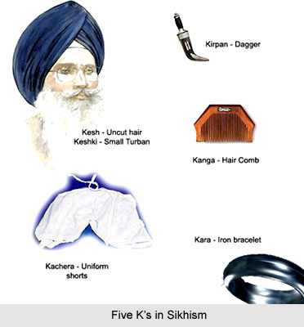 | Key Questions
Khanda | Symbol of the Sikh religion |  | Do Sikhs think it is important to share?  Do religious people lead better lives?  Is religion the most important influence and inspiration in People’s Life?  Do all religious beliefs influence people to behave well towards others?  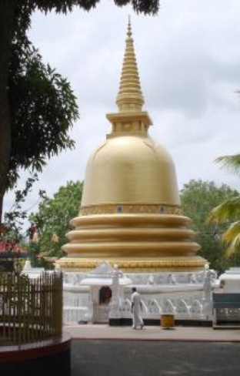
Five K’s | Symbols of allegiance to the Sikh faith
Guru Gobind Singh | Last of the ten human gurus
Kachera | Short trousers or breeches
Kesh | Uncut Hair
Kara | Steel bangle
Kirpan | Small Sword or dagger
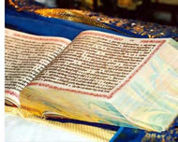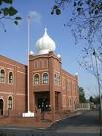 |  | Key Knowledge/Facts
- The last Human Guru was Guru Gobind Singh
- The Sikh community he formed is called the Khasala
- The Five symbols or 5 K’s are known as The Panj Kakka
- They worship at the Gurdwara and the Sikh flag always flies outside
- The Sikh holy book is called The Guru Ganth Sahib
- The Holy city is called Amritsar

