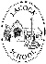
Lacock Primary School – Year 3/4 Beech Class. Rights and Responsibilities (PSHE)
Important Vocabulary |  | Include here images/pictures/maps/diagrams  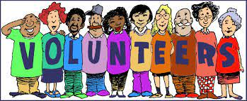  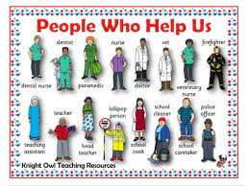  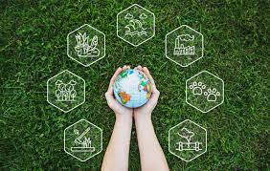 | Key Skills
Volunteer | A person who offers to work or help without being paid. |  | - Sharing our own opinions and being respectful of the fact that other children will have different opinions.  - To work together in pairs or groups.  - To listen carefully to the ideas of others and support our friends.
Emotional wellbeing | Being happy, healthy and comfortable
Fact | Something known or proved to be true. |  | Home ideas…
Opinion | What someone thinks about someone or something. Not necessarily based on facts |  | Can you think of ways in which you can support local or worldwide charities?  Have you considered volunteering before? Maybe it is something you could try to do once before Easter.  Have you thought about what job you would like when you are an adult? Do you know what skills you need in order to achieve that dream?
Recount | To tell a history of events. To list things that have happened in order.
Environment | All the things together that surround animals and humans in the natural world, including air, water and soil.
Income | The money received from work.
Responsibilities | Something for which a person is responsible for. Something you need to do or take care of.
Qualities | A feature that makes a person or thing what it is. Compassion is a good quality to have.
 |  | Key Knowledge/Facts
- To understand what a volunteer is and who in our community is a volunteer.
- To identify key people who are responsible for keeping us safe and healthy.
- To recognise the difference between fact and opinions.
- To recognise ways in which we can look after our school environment
- To understand the terms ‘income’ ‘saving’ and ‘spending’ and understand that people earn their income through their jobs.
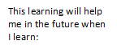
What I should already know:
Paying taxes (yr4) Lending money to people (year 5) What local councils do (year 5) Democracy in Britain (year 6)
How to ask for help if we do not feel safe. How to look after our classroom environment, facts affecting local habitats.

