Lacock Primary School – Year 3/4 Beech Class. Growing and Changing (PSHE)
Important Vocabulary |  | Include here images/pictures/maps/diagrams  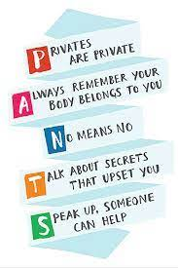  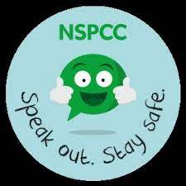  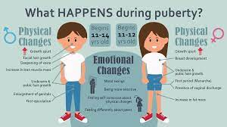  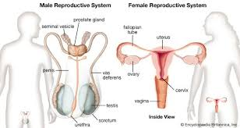 | Key Skills
Relationships | A connection between people |  | - Identifying different types of relationships and how to have positive relationships.  - To understand what is meant by ‘body space’ and when it is appropriate or inappropriate to allow people into our body space.  - To understand the differences between a secret and a surprise.  - To understand and explain what happens during puberty, in particular in girls.  - To learn some basic first aid.
Body space  Personal space | Space that belongs to you as a person – people hugging you or kissing you is coming into your body space / personal person.
strategies | A plan, method or series of action to perform a particular goal – what is your strategy for winning the game? |  | Additional facts / skills learnt
PANTS rule | Teaches you that your body belong you and you have the right to say no.
NSPCC | An organisation set up to protect children and keep them safe.
Secret | Something that is hidden on purpose, something only known to a few people.
Surprise | Something that happens that is not expected.
Puberty | The stage or age at which a person experiences the maturation of the reproductive system
Periods | Something that happens monthly to girls and women. It is how the body gets ready for a baby one day.
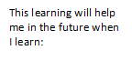
What I should already know:
Understanding puberty even more. What happens to your body when you become a teenager. Recognising different emotions. Sex education (year 6) Pressure from online and the media.
Life stages of plants, animals and humans. Where babies come from. Differences between boys and girls bodies. How to care for a baby. That private body parts are private.

