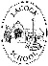
Lacock Primary School – Year 3/4 Beech Class. Being my best (PSHE)
Important Vocabulary |  | 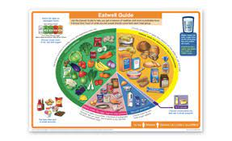  Include here images/pictures/maps/diagrams  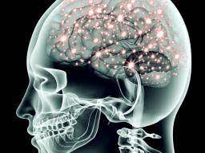  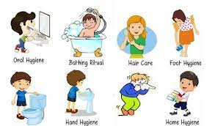 | Key Skills
Eatwell guide | Divides food we eat and drink into 5 main food groups. |  | - Healthy eating  - Infectious illnesses, how they are spread and treated  - Developing our debating skills in a ‘for or against argument’  - Recognise our own achievements and areas for development  - To understand how the brain sends and receives messages through nerves.
Balance diet | A diet of consisting of a variety of different types of food and providing the right amount of nutrients for good health
Food groups | A collection of foods that share similar nutrients |  | Home ideas…
Infectious illnesses | When germs get inside your body, multiply, grown and cause an infection |  | Can you create a healthy meal for your family to enjoy together?  Take some pictures, possibly share the recipes online for us all to share
Hygiene | Practices that you carry out to maintain a healthy lifestyle and stop diseases and infection
Debating | To ‘argue’ about a subject in a formal and polite manner
Achievements | Something that you have done successfully with effort, skill and courage
Areas for development | Something that you have not yet achieved and therefore need to work on
collaboration | The action of working with someone to produce something
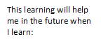
What I should already know:
Making choices, basic first aid, getting fit, independence and responsibility, wellbeing, recognising risks.
Keeping healthy, growth mindset, setting goals, keeping clean and healthy, what my body needs

