Lacock Primary School – Year 3/4 Beech Class. How great is Great Britain? (geography)
Important Vocabulary |  | Include here images/pictures/maps/diagrams  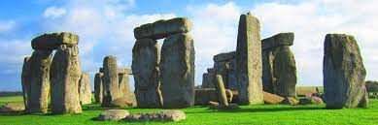  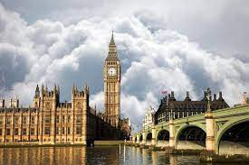  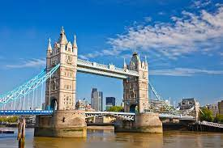  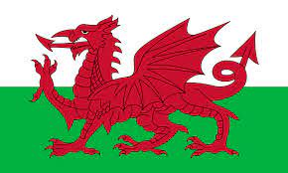  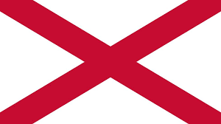  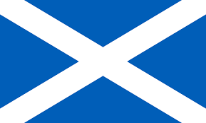  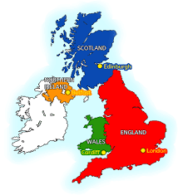 | Key Skills
county | A small area of the UK containing lots of towns and villages |  | - To name and locate the countries and cities of the UK, using the eight compass points  - To name and locate the main rivers and seas of the UK and identify them using maps and atlases.  - To name and locate some of the counties of the UK, locating them on a map.  - To name and locate areas of high ground in the UK, using maps and atlases.  - To identify ways in which London has changed over time, explain the important of Prime Meridian to its history.  - To describe and understand how the UK has changed over time.
Prime meridian | An imaginary line which divides the Earth into the eastern and western hemispheres.
Immigration | People moving to another country to live there permanently. |  | Home learning
UK | The United Kingdom of Great Britain and Northern Ireland. |  | Our county flag and coat of arms.  - Can you find out what the flag and coat of arms is for our county, Wiltshire?  - Draw a picture of it / them.  - Why was it chosen? What does each part represent?  - Have a go at designing your own county flag / coat of arms that shows what is important to you?
Great Britain | England, Scotland and Wales
Landmark | A feature of the landscape or area that is easily recognised
Millennium | A time period of 1,000 years. The new Millennium started 1st January 2000
Include here images/pictures/maps/ diagrams |  | Key Knowledge/Facts
- The UK is short from the United Kingdom of Great Britain and Northern Ireland
- The capital cities are: London (England) Edinburgh (Scotland) Cardiff (Wales) Belfast (Northern Ireland)
- The highest mountains in Great Britain are: Snowden (Wales) Ben Nevis (Scotland) and Scafell Pike (England)
- We are an island, surrounded by the seas: Irish Sea, North Sea, English Channel, Atlantic Ocean
- Counties have control over the local area and services within them (police, schools, transport)
What I should already know:
This learning will help me in the future when I learn:
Locate other countries of the world, identify features of the world (Equator, Latitude, Longitude, Tropics of Cancer and Capricorn)
Naming and locating the seven continents and five oceans.
Name the capital cities of the UK

