Lacock Primary School – Year 3/4 Beech Class. Programming – sequence in music (Computing)
Important Vocabulary |  | Include here images/pictures/maps/diagrams  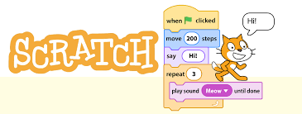  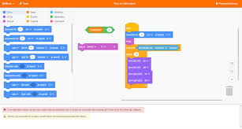 | Key Skills
Scratch | Scratch is a free programming language and online community where you can create your own interactive stories, games, and animations. |  | - To explore a new programming environment  - To identify that commands have an outcome  - To explain that a program has a start  - To recognise that a sequence of commands can have an order  - To change the appearance of my project  - To create a project from a task description
programming | Writing a group of instructions for a computer to process and carry out. |  | Home learning
commands | To order or instruct. |  | Look out for an additional homework sheet placed in their homework folders for a couple of weeks.
code | A system of using symbols or signals in place of letters and numbers.
sprite | A small supernatural creature – the characters within Scratch
motion | An instance of movement.
sequence | A pattern or process which one thing follows another.
chord | Three of more musical notes played at the same time
Algorithm | A procedure for solving a problem – used in maths and computing
bug | A mistake of fault that keeps something from working properly.
debug | To find and remove mistakes in a computer programme
What I should already know:
This learning will help me in the future when I learn:
Repetition in shapes (year 4)
Selection in physical computing (year 5)
Variables in games (Year 6)
Moving a robot (Year 1)
Robot algorithms (Year 2)

