Lacock Primary School – Year 3/4 Beech Class. Programming – events and actions (Computing)
Important Vocabulary |  | Include here images/pictures/maps/diagrams  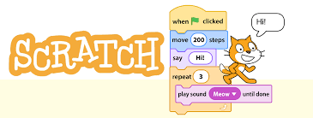  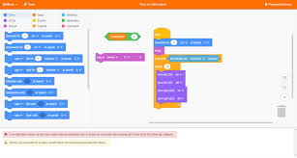 | Key Skills
motion | An instance of movement. |  | - To explore how a sprite moves in an existing project.  - To create a program to move a sprite in four directions.  - To adapt a program to a new context.  - To develop my program by adding features.  - To identify and fix bugs in a program.  - To design and create a maze-based challenge.
sprite | A small supernatural creature – the characters within Scratch |  | Any additional facts / skills learnt
Algorithm | A procedure for solving a problem – used in maths and computing
Logic | A way of solving a problem that uses careful thought and reasoning
resize | To make a figure larger or smaller while keeping the angles and proportions that same.
debugging | To find and remove mistakes in a computer programme
What I should already know:
This learning will help me in the future when I learn:
Repetition in games (year 4)
Selection in quizzes (year 5)
Sensing (Year 6)
Introduction to animation (Year 1)
An introduction to quizzes (Year 2)

