Lacock Primary School – Year 3/4 Beech Class. Branching databases (Computing)
Important Vocabulary |  | Include here images/pictures/maps/diagrams  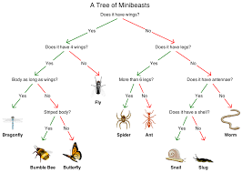  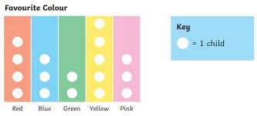  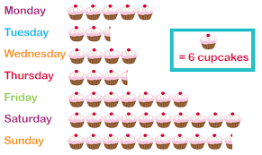 | Key Skills
Attribute | A characteristic or quality. A sour taste is an attribute of a lemon. |  | - To create questions with yes/no answers.  - To identify the object attributes needed to collect relevant data.  - To create a branching database  - To explain why it is helpful for a database to be well structured.  - To identify objects using a branching database  - To compare the information shown in a pictogram
Branching database | A way of classifying (grouping) objects based on similar or different attributes.
database | A collection of data (information) that is stored on a computer. |  | Curriculum links
structure | The way a thing is made up of a number of parts joined together. |  | - Maths – collecting and presenting data  - Science – asking questions, presenting data, characterists
selecting | To choose or to pick.
pictogram | A representation of data through the use of pictures
compare | To describe the similarities and differences between things.
Decision tree | Used for making decisions in computer programming.
Include here images/pictures/maps/ diagrams |  | Key Knowledge/Facts
- In a pictogram, the picture can represent more than 1 person or object. You could use a circle representing 10 children when asking them their favourite colour. If only 5 children liked blue, you would draw half a circle.
- We are going to be using j2 data to create our branching trees and pictograms.
- It is called a Branching database as the lines look like the branches from a tree!
What I should already know:
This learning will help me in the future when I learn:
Data logging (year 4)
Flat-file databases (year 5)
Spreadsheets (Year 6)
Grouping information (Year 1)
Pictograms (Year 2)

