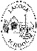
Lacock Primary School Year 1/2 – Great Fire of London
8000BCE
1939-45
1914-18
Now
1837
1666
1485
1066
790 CE
43 CE
800 BCE
2300 BCE
Vikings
Tudors
Victorians
Normans
Romans
Bronze Age
Iron Age
Stone Age
Great Fire of London
Tudors
World War II
World War I
Modern Day
Important Vocabulary |  | 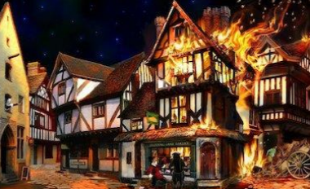  In1666, lots of people had houses made from wood and straw which burned easily. Houses were also built very close together.  There had been no rain so the buildings were very dry and a gentle breeze blew the fire from one house to another. | Key Skills
Bakery | A place where bread and cakes are made |  | - To place events on a timeline  - To recognise similarities and differences to today  - To understand how we find out about the past and sources of evidence.
London | The Capital city of England
Diary | A book where people write about their lives |  | Important People
King Charles II | The King of England at that time |  | 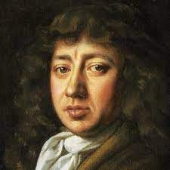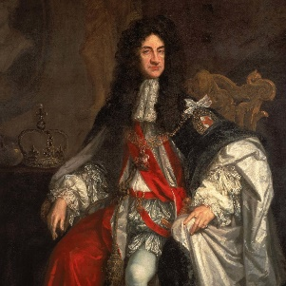  Samuel Pepys King Charles II  A famous man who wrote about The King of England in 1666  the fire in his diary.
1666 | The year that the fire started
Eyewitness | Someone who saw something happen
Thatched roof | A roof made from straw
Flammable | A material that can easily catch fire.
Tower of London | The King lived here in 1666
Fire Fighting tools  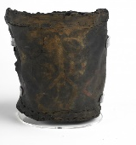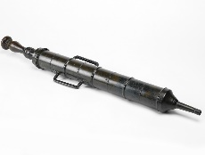  Leather bucket Water squirt |  | Key Knowledge
- 2nd September 1666 Fire started in Thomas Farriner’s Bakery in Pudding Lane.
- 3rd - September 1666 Fire continued to spread
- 4th September St Paul’s Cathedral caught fire
- 5th September Wind dropped so fire slowed down
- 6th September Fire was put out. Only 6 people died.
- We know about the fire because people wrote about it in letters and in diaries.
What I should already know:
Pirates – Golden age of Piracy was in 1600s too.
Guy Fawkes and the Gunpowder Plot 1605

This learning will help me in the future when I learn:

