School Vision, Ethos and Values

Our Vision:
Our school was donated to the people of Lacock in 1824 by our most famous resident William Henry Fox Talbot, who invented photography. We are so proud of our heritage, and this is reflected in us choosing a photography based image through which we can express our school vision.
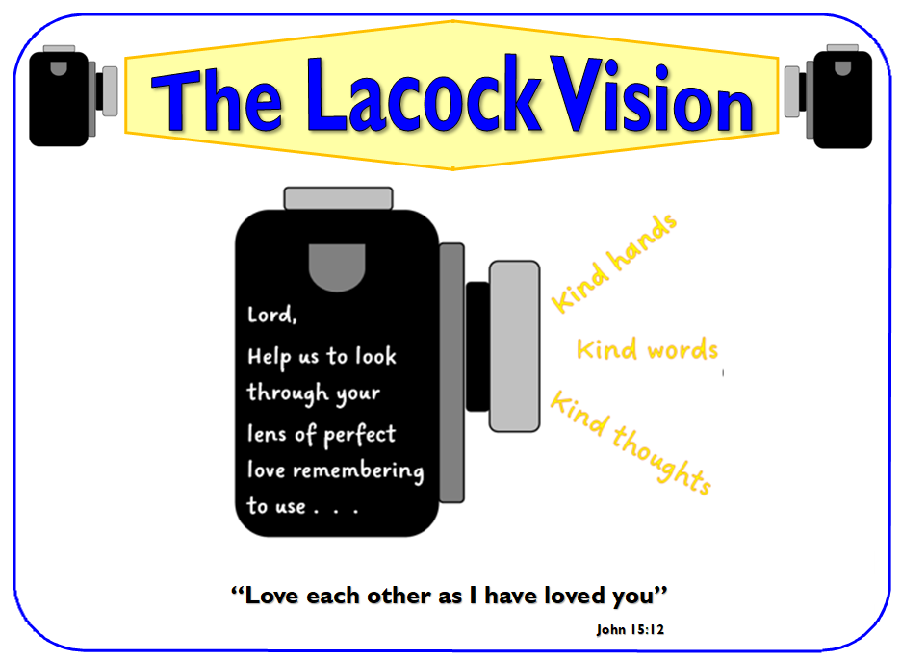

At Lacock Church of England Primary School we aim to put love at the centre of all we do. Our School Christian vision is based on Jesus’s command that we should love one another as He loves us. As a Church School, we believe our children receive an education in an environment that is distinctively Christian in character through daily acts of worship, times for prayer and reflection and our strong partnership with St Cyriac’s Church Lacock. We pray that God helps us to look through his ‘lens’ of perfect love, where everyone is precious. We encourage each other to put this into action by having kind thoughts and using kind words and hands. Our vision influences and shapes all that we do.

Our Aims:
Lacock Church of England Primary School will help all members of the school family and community to:
- that our children enjoy learning and are confident and willing to try
- ensure that our children feel safe, loved, valued and will flourish as a result of this care
- grow with respect and understanding for others
- foster curiosity and creativity and develop a lifelong love of learning
- develop skills that enable positive relationships to blossom
- gain the skills, resilience and adaptability to thrive in a rapidly changing and diverse world
- to ensure the well-being and mental health of every member of the school community is supported
- to promote the Christian values and spiritual development for all through Collective Worship and all our interactions each day
- to grow in their understanding of the Christian faith and their own spirituality and beliefs
- promote high academic standards and ensure the needs of every child are met
- enable teachers, parents and carers to work together as partners in their children’s education
- feel listened to and able to raise concerns on behalf of others in the spirit of courageous advocacy

At Lacock, we try to make sure the children in our care have the best educational start and that the important foundations we lay will stay with them throughout their lives.

Our Ethos:
Teach a child in the way they should go, and even when they are old they will not depart from it"
Proverbs 22:6
We believe that this verse can be viewed both in terms of educational learning and development of character.
Throughout our learning runs a golden thread of Christian love expressed through our school vision in partnership with the Lacock Way which unites us as a loving family coming together.

Our Values:
Our stakeholders agreed on 12 core values which are strategic to this vision. These are:-

Term | Year A | Year B
1 | Generosity | Thankfulness
2 | Service/Christmas | Compassion/Christmas
3 | Truthfulness | Trust
4 | Hope | Forgiveness
5 | Friendship | Respect
6 | Courage | Perseverance
All we do as a school is underpinned by these values.
We believe our Christian values are empowering our pupils to develop their spirituality and guiding them in personal development as effective learners and good citizens of the world. All children take part in daily Collective Worship which is planned around the school’s chosen values as well as the main celebrations in the Christian calendar.
At the end of each week, we celebrate children who have put the term’s Christian Value into action during the week by presenting them with a certificate during our Celebration Collective Worship with parents attending. These children are given the opportunity to share what they have been doing and become role models for the rest of the school community. Certificates are presented to both staff and children.

British Values
The government defines British values as Democracy, Rule of law, Individual liberty, Mutual respect and tolerance of those of different faiths. At Lacock School, we actively promote British values through our school vision, ethos, agreed rules, aspirational curriculum and quality-first teaching. As such, we promote tolerance of and respect for, people of all faiths and those with no faith.

Collective Worship
Our Collective Worship values are:-
Generosity
Everything we have is a gift from God and because we are thankful for his vast generosity, we can be generous to others.
Corinthians 9.7: God loves a cheerful giver
Compassion
We are kind and compassionate to one another, forgiving each other, just as God forgave us.
2 Colossians 3.12: Clothe yourselves with compassion, kindness, humility, gentleness and patience.
Forgiveness
Everyone makes mistakes, it's part of being human. Sometimes mistakes hurt others and we need to say sorry.
Ephesians 4.32: Be kind and compassionate to one another, forgiving each other, just as in Christ God forgave you.
Friendship
Friends are incredibly important. As part of this value we consider how to be a good friend and how to encourage each other.
Proverbs 17.17: A friend loves at all times.
Respect
Respect is about valuing everyone and everything and celebrating our differences. We are all God's people and we all matter. Respect involves taking responsibility for each other and speaking and interacting with others in a courteous manner.
1 Peter 2.17: Show proper respect to everyone
Perseverance
Perseverance is about keeping on trying in the face of a challenge.
Philippians 4.13 I can endure all these things through the power of the One who gives me strength

Hope
Hope is much more than a general idea that things will get better. Christian hope is rooted in the love and faithfulness.
Jeremiah 29.11: For I know the plans I have for you, declares the Lord, plans for welfare and not for evil, to give you a future and a hope.

Thankfulness
Thankfulness is not just remembering our manners. Christian thankfulness is the belief that God loves and cares for us in many ways in all aspects of our life. Christians know that their response to this provision should be one of thankfulness and praise.
Psalm 136: Give thanks to the Lord for he is good. His love lasts forever.

Service
With service we look to serve each other as well as God, Jesus shows us how to live a life of service to others.
1 Peter 4:10-11: Each of you should use whatever gift you have received to serve others

Courage
God encourages us to be courageous when times are difficult and that we should keep trying in times of difficulty for He is with us.
Joshua 1:9: Have I not commanded you? Be strong and courageous. Do not be afraid; do not be discouraged, for the Lord your God will be with you wherever you go.

Trust
We learn together that trust is not just something we do but also something we need to earn from others.
1 Corinthians 13:6-7: Love does not delight in evil but rejoices with the truth. It always protects, always trusts, always hopes, always perseveres.

Truthfulness
We learn that telling the truth helps establish the right relationships with each other as we grow together as a school community.
Ephesians 4:25: So stop lying to each other. Tell the truth to your neighbour.

