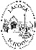
Lacock Primary School – Year 3/4 Beech Class. How great is Great Britain? (Art)
Important Vocabulary |  | Include here images/pictures/maps/diagrams  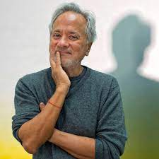  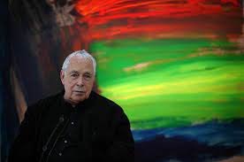  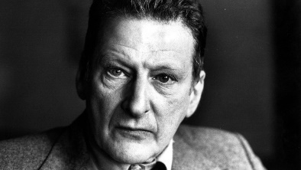  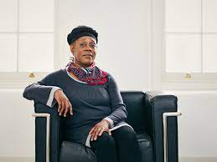  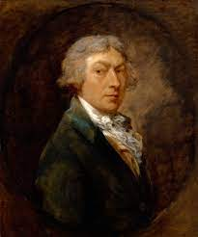  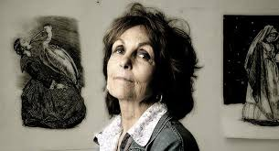 | Key Skills
Folk tales | A story originating in popular culture, usually spread by word of mouth (not always written down) |  | - To draw illustrations in the style of Paula Rego.  - To paint famous artworks in the style of Gainsborough.  - To paint in the style of Sonia Boyce.  - To make a portrait in the style of Lucian Freud  - To paint in colour using Howard Hodgkin as an influence  - To learn about Anish Kapoor’s life and work
illustrations | A picture or diagram that explains or describes.
architects | A person who designs buildings or sculptures |  | Home learning
foreground | The part of a view that is nearest to the person looking at it. |  | Choose one of the following activities to complete at home:  - Paula Rego often uses traditional Portuguese stories or fairy tales to inspire her paintings. Choose one of the following stories and design a front cover for the book. (The Gingerbread man, Rumpelstiltskin, Cinderella, The Evles and the Shoemaker, Hansel and Gretel, Snow White and the seven Dwarves, The Little Red Hen, Three Billy Goats Gruff)  - If possible using a computer, can you make an abstract picture called ‘Cold’ inspired by Howard Hodgkin.
Middle ground | The space occurring between the foreground and the background
Afro Caribbean | A person of African descent living in or coming from the Caribbean
portrait | A painting, drawing, photograph or carving of a person, mainly just the face or head and shoulders
abstract | Art using shapes, colours and line to create a picture. It does not attempt to be a ‘real or accurate’ representation.
Include here images/pictures/maps/ diagrams |  | Key Knowledge/Facts
- Paula Rego was born in Portugal but lived most of her life in Britain and considers herself British. She often paints women in her pictures. They are usually showing a type of emotion.
- Thomas Gainsborough usually paints landscapes, although these were usually imaginary and not of real places that he has seen or visited.
- Sonia Boyce uses bold patterns and bright colours to show the Caribbean side of her background.
- Lucian Freud used plain backgrounds in his paintings, so that the other colours stood out more.
- Howard Hodgkin took a long time to create his work of art – sometimes up to 9 years!
- Anish Kapoor uses granite, marble, plaster and limestone to create his sculptures.
What I should already know:
This learning will help me in the future when I learn:

